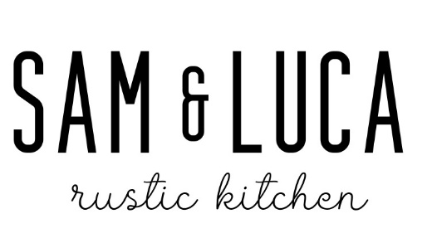
4-Courses $60
Salad
Caesar Salad
House Caesar dressing, parmesan, croutons
Pasta Course
Butternut Squash Ravioli
house made butternut squash ravioli topped with crispy almonds in a light Amaretto herb sauce
Choice of Entree
Seafood Risotto
Sun-dried tomato, spinach, toasted pine nuts shrimp
Brasato
Wine braised short rib, wild mushroom, asiago, spinach risotto with rosemary demi
Ancho Salmon
Norwegian Salmon, tomato, asparagus, brown butter, fig balsamic
Piccata
Chicken, lemon, capers, with fettuccini alfredo

Sweet Ending
Limoncello Tiramisu
Chocalate Mousse Cake

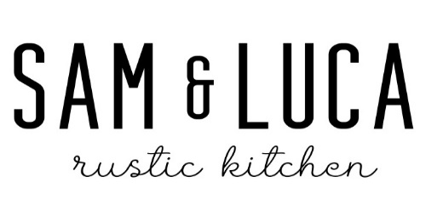
3-Courses $55
Salad
Caesar Salad
House Caesar dressing, parmesan, croutons
Choice of Entrée
Seafood Risotto
Sun-dried tomato, spinach, toasted pine nuts shrimp
8 oz Filet Mignon
Pine nut, spinach, wild mushroom risotto with rosemary demi
Ancho Salmon
Norwegian Salmon, tomato, asparagus, brown butter, fig balsamic
Piccata
Chicken, lemon, capers, with fettuccini alfredo
Sweet Ending
Limoncello Tiramisu
Salted Caramel Cheese Cake
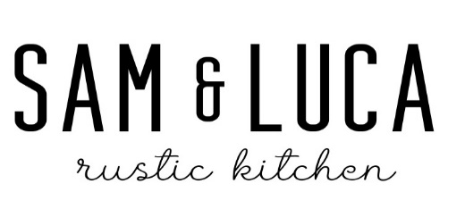
4- Courses $65
Salad
Rustico Salad
Tomato, olives, pepperoncini, mozzarella, onion, herb vinaigrette

Pasta Course
Butternut Squash Ravioli
butternut squash ravioli topped with crispy almonds in a light amaretto herb sauce

Choice of Entree
8 oz Filet Mignon
Pine nut, spinach, wild mushroom risotto with rosemary demi
Piccata
Chicken, lemon, capers, with fettuccini alfredo
Ancho Salmon
Norwegian Salmon, tomato, asparagus, brown butter, fig balsamic
Brasato
Wine Braised short rib, wild mushroom, asiago, spinach risotto, pine nuts jus
Sweet Ending
Tiramisu
Salted Caramel Cheesecake

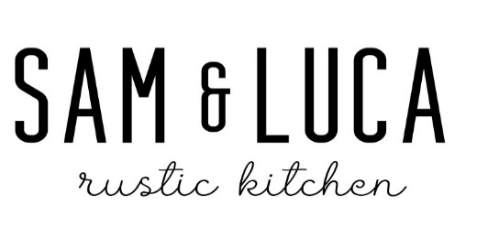
4-Courses $65
Appetizer
Classic Bruschetta
Rustic Board
marinated vegetables & olives, Italian meats & cheeses, candied walnuts
Salad
Rustico Salad
Tomato, olives, pepperoncini, mozzarella, onion, herb vinaigrette
Choice of Entree
8 oz Filet Mignon
Pine nut, spinach, wild mushroom risotto with rosemary demi
Piccata
Chicken, lemon, capers, with fettuccini alfredo
Pappardelle Bolognese
House made with braised veal, pork, & beef
Shrimp Scampi
Roasted tomato, capers, white wine, scampi butter, breadcrumbs, linguine
Sweet Ending
Limoncello Tiramisu
Chocolate Mousse Cake
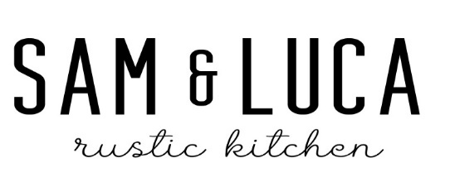

4-Courses $60
Appetizer
Rustic Board
marinated vegetables & olives, Italian meats & cheeses, candied walnuts
Salad
Strawberry Salad
Spinach, strawberries, feta, walnuts, maple-balsamic vinaigrette

Entrees
Ancho Salmon
Norwegian Salmon, tomato, asparagus, brown butter, fig balsamic
Brasato
Wine Braised short rib, wild mushroom, asiago, spinach risotto, pine nuts jus
Piccata
Chicken, lemon, capers, with fettuccini alfredo
Shrimp Scampi
Roasted tomato, capers, white wine, scampi butter, bread crumbs, linguine
Sweet Ending
Limoncello Tiramisu
Chocolate Mousse Cake

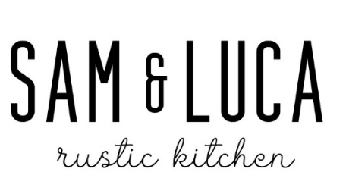

4-Courses $50
Appetizer
Rustic Board
marinated vegetables & olives, Italian meats & cheeses, candied walnuts
Salad
Strawberry Salad
Spinach, strawberries, feta, walnuts, maple-balsamic vinaigrette
Entrees
Ancho Salmon
Norwegian Salmon, tomato, asparagus, brown butter, fig balsamic
Marsala
Chicken, shallots, mushrooms, brown sauce on a bed fettuccini|
Lasagna
With house made Bolognese and bechamel
Pappardelle Bolognese
House made with braised veal, pork, & beef

Sweet Ending
Limoncello Tiramisu
Chocolate Mousse Cake

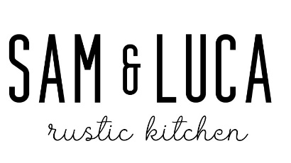

3-Courses $55

Salad
Caesar Salad
House Caesar dressing, parmesan, croutons
Entrée
Lasagna
With house made Bolognese and bechamel
Seafood Risotto
Sun-dried tomato, spinach, toasted pine nuts shrimp|
Ancho Salmon
Norwegian Salmon, tomato, asparagus, brown butter, fig balsamic
Brasato
Wine Braised short rib, wild mushroom, asiago, spinach risotto, pine nuts jus

Sweet Ending
Limoncello Tiramisu
Chocalate Mousse Cake

3-Courses $45

Salad
Strawberry Salad
Spinach, strawberries, feta, walnuts, maple-balsamic vinaigrette

Entrée
Pollo Fettuccine Alfredo
Grilled Chicken, alfredo

Shrimp Scampi
Roasted tomato, capers, white wine, scampi butter, bread crumbs, linguine

Piccata
Chicken, lemon, capers, with fettuccini alfredo

Pappardelle Bolognese
Housemade with braised veal, pork, & beef

Sweet Endings

Aliya’s Salted Caramel Cheesecake
Limoncello Tiramisu

